Lab :9
Tasks :1
Write an assembly language that compares the values A and B and prints a message if the value in A is greater than B, less than B.

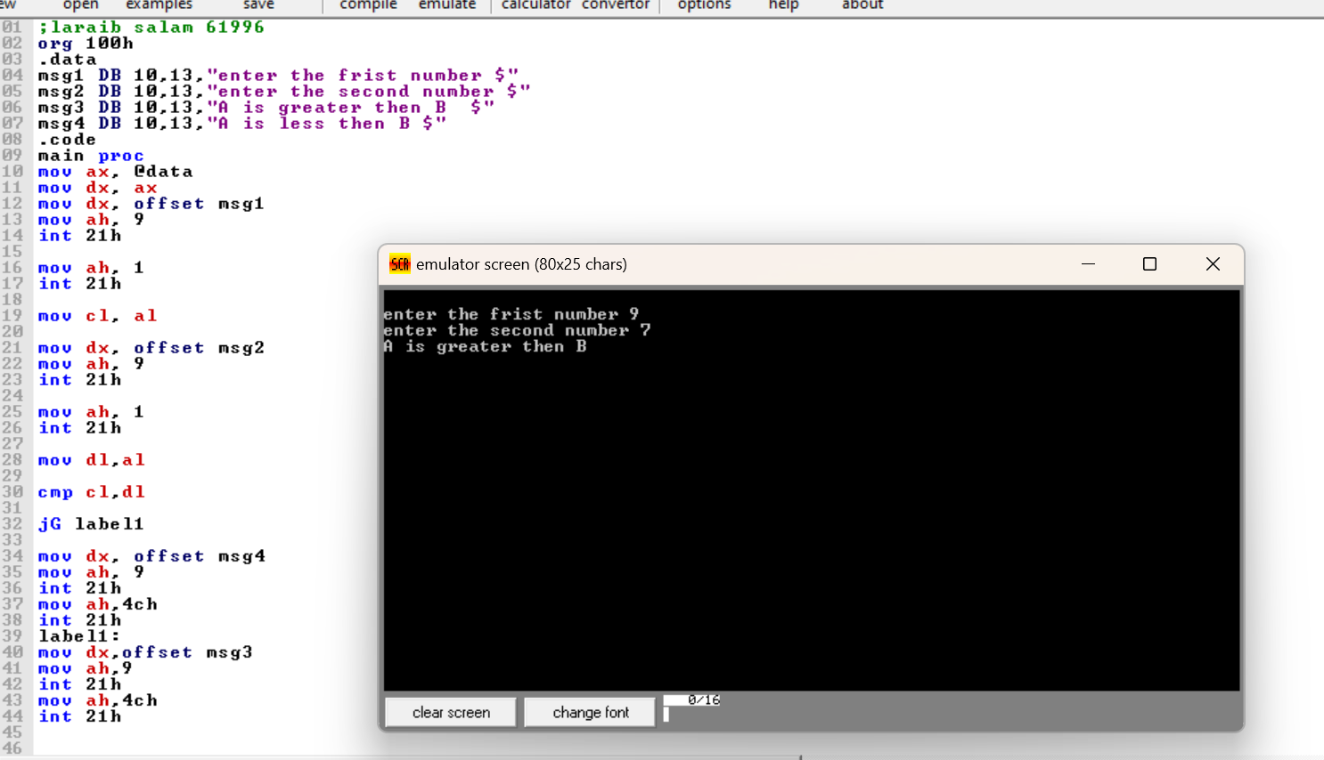
Tasks :2
